Christeen Safar

CSD - 340

03/19/2023

**Module 2 Assignment 2.2- Assignment: Building a Web Page Exercise, Part 2**

**1. Assignment Instructions Step up:**

**GitHub Link:**

[**https://github.com/ChristeenSS/csd-340.git**](https://github.com/ChristeenSS/csd-340.git)

* Create a new directory under your local csd-340 folder (repository) and name it module-2
* Create a new HTML document and name it <LastName_Mod2_2>.html and add it to your module-2 directory
* Create a new CSS document and name it <LastName_Mod2_2>.css and add it to your module-2 directory

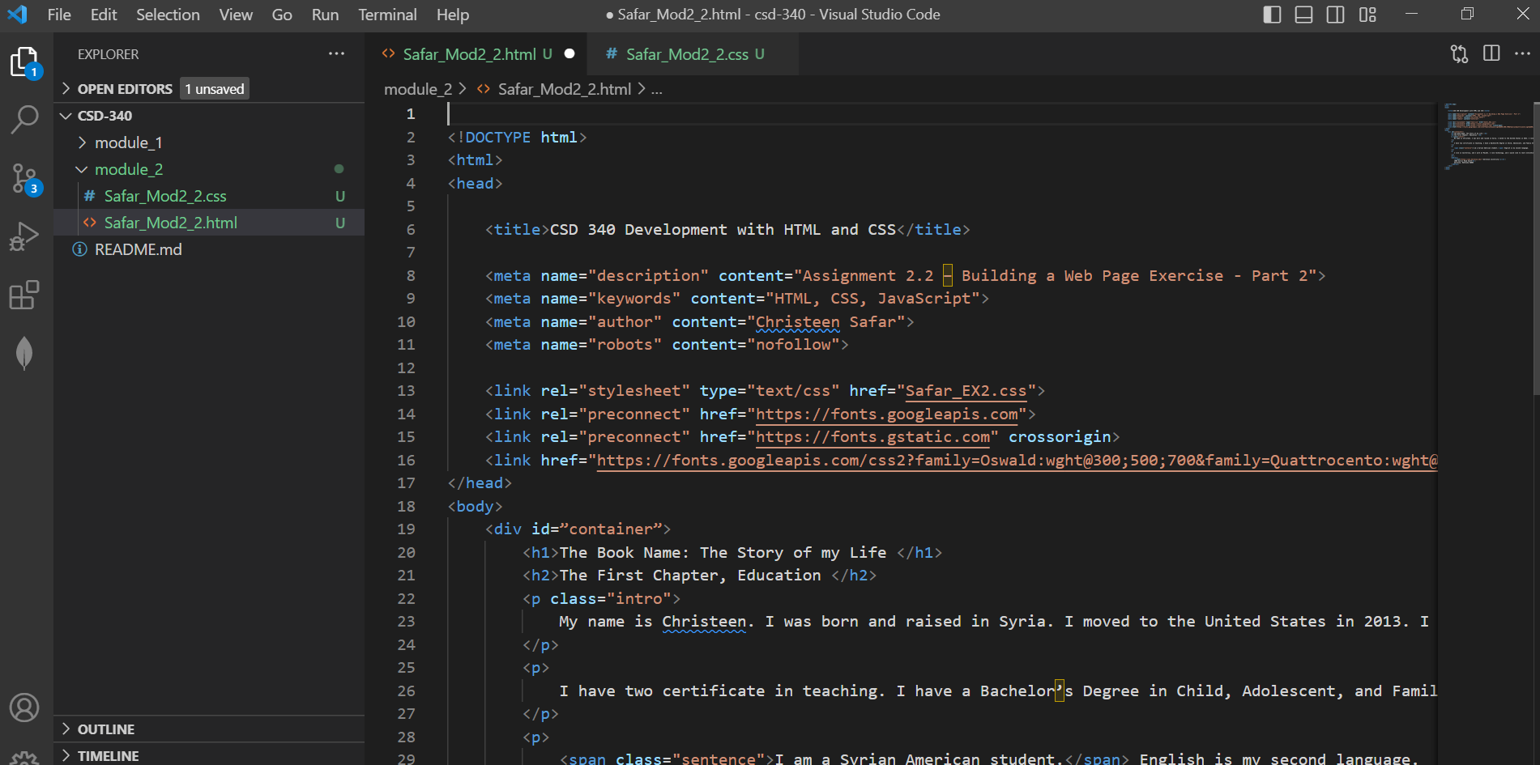

* Using what we learned from Module 1, build a new HTML page, add your name and assignment number (documentation) and make sure it validates with 0 errors.
* Contents of   <LastName_Mod2_2>.html



<!DOCTYPE html>

<html>

<head>

    <title>CSD 340 Development with HTML and CSS</title>

    <meta name="description" content="Assignment 2.2 – Building a Web Page Exercise - Part 2">

    <meta name="keywords" content="HTML, CSS, JavaScript">

    <meta name="author" content="Christeen Safar">

    <meta name="robots" content="nofollow">

    <link rel="stylesheet" type="text/css" href="Safar_EX2.css">

    <link rel="preconnect" href="https://fonts.googleapis.com">

    <link rel="preconnect" href="https://fonts.gstatic.com" crossorigin>

    <link href="https://fonts.googleapis.com/css2?family=Oswald:wght@300;500;700&family=Quattrocento:wght@400;700&display=swap" rel="stylesheet">

</head>

<body>

    <div id=”container”>

        <h1>The Book Name: The Story of my Life </h1>

        <h2>The First Chapter, Education </h2>

        <p class="intro">

            My name is Christeen. I was born and raised in Syria. I moved to the United States in 2013. I love Reading books, Listening to Classical Music, and Traveling.

        </p>

        <p>

            I have two certificate in teaching. I have a Bachelor’s Degree in Child, Adolescent, and Family Studies from California State University, Bakersfield. Also, I have a Bachelor’s Degree in Elementary Education and Teaching from Syria.

        </p>

        <p>

            <span class="sentence">I am a Syrian American student.</span> English is my second language.

        </p>

        <p>

            I live in California, and I work at Macy’s. I love technology, and I would like to learn everything about software development and programming.

        </p>

        <hr/>

        <address>

            <a href="https://www.bellevue.edu/">bellevue university</a><br/>

            1000 Galvin Road South<br/>

            bellevue, Nebraska 68005

        </address>

    </div>

</body>

</html>

**2. Assignment Instructions Step 2**

Safar_Mod2_2.css

html, body {

    font-size: 16px;

}

p {

    font-family: 'Quattrocento', Georgia, "Times New Roman" serif;

    font-weight: 400;

    line-height: 1.4em;

}

h1 {

    font-weight: 700;

    text-transform: capitalize;

    font-size: 3.052em;

    word-spacing: .5em;

    margin: 0;

    text-align: center;

}

h2 {

    font-weight: 500;

    font-size: 2.441em;

    word-spacing: .2em;

    margin: 0;

    text-align: left;

    padding-top: 15px;

}

address {

    font-family: 'Quattrocento', Georgia, "Times New Roman" serif;

    text-align: center;

}

a {

    text-transform: bold;

    font-size: 1.25em;

    color: #4f3674;

    text-decoration: none;

}

a:hover {

    color: #D6A800;

    text-decoration: underline;

}

a:visited {

    color: #000000;

}

.sentence {

    font-style: italic;

}

.intro {

    text-indent: .2em;

}

**3. The Output:**

